# Unit 4: Do we find happiness in ability?

## Overview

We often define ourselves by the things we are good at and the things we are not good at. The balance between these sides shapes our self-esteem – whether we believe that we are capable, confident contributors, or whether we feel useless and incompetent. On the one hand, if we focus entirely on our abilities and strengths, we risk becoming narcissistic. On the other hand, if we dwell on our worthlessness and our deficits, we plunge into depression and dysfunction. What is a healthy way to think about ability and disability? In this unit, we will consider the definitions of these concepts and their relationship to finding the good life.

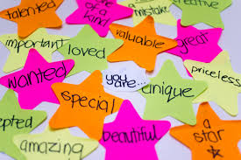

Figure 4.1. "self-esteem" flickr photo by Kiran Foster https://flickr.com/photos/rueful/8065467654 shared under a Creative Commons (BY) license

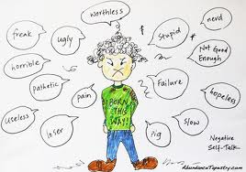

Figure 4.2 Negative Self-Talk from <https://www.evelynlim.com/25-labels-in-your-negative-self-talk/>

## Prompts

Unit 4 will look at two prompts, both speeches but in very different contexts:

1: Frank Stephens’ speech to the US Congress

2: Henri Nouwen’s sermon, “Being the beloved”

## Learning Outcomes

Through practicing inquiry in this unit, you will:

* Examine your pre-existing beliefs about ability and disability
* Analyze and discuss Frank Stephen’s speech about Down syndrome
* Analyze and discuss Henri Nouwen’s sermon
* Question the meaning and place of ability in the context of the good life
* Reflect on the implications of being “beloved” in the eyes of God

## Activity Checklist

Here is a checklist of learning activities you will benefit from in completing this unit. You may find it useful for planning your work.

|  |  |
| --- | --- |
| 🗹 | **Activities** |
|  | Activity 4.1: In your journal, respond to the Albert Einstein quote. |
|  | Activity 4.2: Watch the short video, “Not special needs” |
|  | Activity 4.3: Read the background information to provide the context of Frank Stephen’s speech. |
|  | Activity 4.4: Watch the [full speech](https://www.youtube.com/watch?v=yQJEoRhkapw) and analyze the quotes provided. |
|  | Activity 4.5: Read the introduction and background on Henri Nouwen. |
|  | Activity 4.6: Listen to the full sermon. |

**Assessment**

Here is the assessment for this unit.

|  |  |
| --- | --- |
| **Group discussion**: Do we find happiness in ability?  Meet with your group to discuss what Nouwen’s sermon means to you and how it helps you think about the concept of ability. Complete the Group Discussion Template as a record of your discussion and post it. | 2% |

## Prompt 1:

In recent years, social media has helped to increase the profile of people with Down syndrome. World Down Syndrome Day began in 2012, setting aside March 21 (3/21) annually. In February 2018, it was announced that the newest “Gerber Baby” (the advertising face for the Gerber company) is a baby with Down syndrome. A recent comic book called *Superb* features a superhero who has Down syndrome. Tim Horton’s has featured employees who have Down syndrome, and multiple videos have highlighted the contributions of people with Down syndrome to the positive environment of their restaurants and other businesses. The speech which is today’s prompt was also trending on social media, but unlike the others, it provides us with a first-hand perspective from an adult who has Down syndrome. We will consider the question, “Do we find happiness in ability?” as we listen to Frank Stephen’s message.

### Learning Activities

#### Activity 4.1: Journal Response

Read and respond to the famous quote by Einstein. Spend approximately 5 minutes in your journal. What do you say to Einstein?

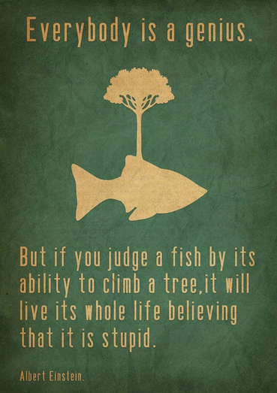

[Use image above if we can find original source and it is CC. Otherwise, use image below]

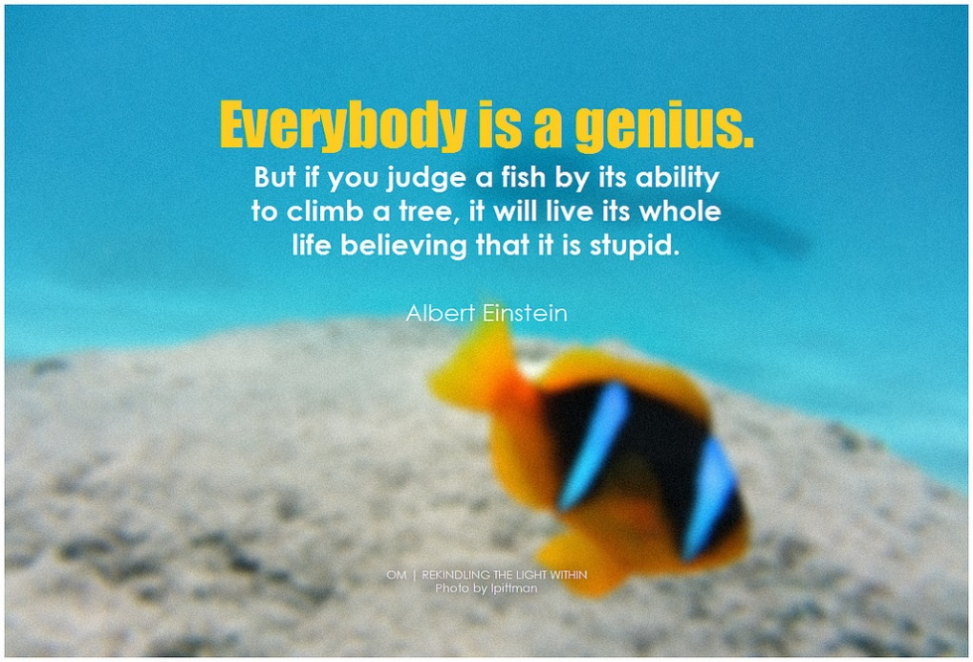

Figure 4.1 "Albert Einstein Everybody is a genius. But if you judge a fish by its ability to climb a tree, it will live its whole life believing that it is stupid" flickr photo by symphony of love https://flickr.com/photos/pictoquotes/15017154130 shared under a Creative Commons (BY-SA) license

#### Activity 4.2: Video

Watch the short video, “[Not special needs](https://www.youtube.com/watch?v=tZ7l-lFJpR0),” a trending video on social media in 2018.

Think about these questions:

* How has the term “special needs” impacted your view of ability and disability?
* How can we define “ability” and “disability?”

#### Activity 4.3: Frank Stephen

Read the background information to provide the context of Frank Stephen’s speech.

**Down Syndrome**

* The common name for a chromosomal difference – a full or partial trisomy of the 21st chromosome, which means that genetic information is copied three times instead of twice.
* Named after John Langdon Down, a British physician who first published on the syndrome in 1866.
* Most commonly, the chromosomal behaviour occurs during the process of cell division.
* Life expectancy has changed from age 9 in 1910 to age 60 at the current time.
* Quality of life has changed dramatically with family, educational, community, and career support
* See [National Down Syndrome Society](https://www.ndss.org/about-down-syndrome/down-syndrome/) for more information

**Frank Stephens**

* American speaker, writer, advocate, athlete, model, and actor who has Down syndrome
* In 2012, CBC listed him as one member of “The most extraordinary ordinary people”
* In 2016, was awarded the [QUINCY JONES EXCEPTIONAL ADVOCACY AWARD](https://bebeautifulbeyourself.org/quincy-jones-exceptional-advocacy-award/) from the Global Down Syndrome Foundation
* Award recognizes people who advocate for those who are “differently-abled” and to highlight people of all abilities who contribute to society

**Context of the Speech**

* Delivered to the US Congress
* Focuses on the need for more research funding related to Down Syndrome and how understanding it more can contribute to other medical research
* Emphasizes that he has a great life
* Argues against the message that Down syndrome should be eliminated via genetic screening and abortion
  + “Many of those living with Down syndrome are understandably dismayed at the implication that their extra chromosome renders their life more trouble than it is worth” (Friedersdorf, 2017).
  + [Media](https://www.cbsnews.com/news/down-syndrome-iceland/) has widely reported statistics related to abortion rates, particularly regarding Iceland, where it is reported that almost 100% of babies are aborted if detected by screening tests and found to have Down syndrome.

#### Activity 4.4: Watch and Analyze

Watch the [full speech](https://www.youtube.com/watch?v=yQJEoRhkapw) by Frank Stephens.

Next, analyze and discuss the speech, specifically the sections and questions below. You may want to share some your thoughts with your group as you meet this week. (Ungraded prompt)

|  |
| --- |
| “Just so there is no confusion let me say that I am not a research scientist. However, no one knows more about life with Down Syndrome than I do. Whatever you learn today, please remember this: **I am a man with Down Syndrome and my life is worth living**.” |

**Discuss:**

* Why does it matter that Frank’s authority comes not from academia but from everyday life?
* Discuss his main idea (in bold). What does this mean to you?

|  |
| --- |
| Sadly, across the world, a notion is being sold that maybe we don't need research concerning Down Syndrome. Some people say prenatal screens will identify Down Syndrome in the womb and those pregnancies will just be terminated.  It's hard for me to sit here and say those words.  I completely understand that the people pushing this particular “final solution” are saying that people like me should not exist. That view is deeply prejudice by an outdated idea of life with Down Syndrome. |

**Discuss:**

* What do Frank’s words say to us about our society’s beliefs about ability? About the connection to the good life?

|  |
| --- |
| Seriously, I have a great life!  I have lectured at universities, acted in an award-winning film and an Emmy-winning TV show, and spoken to thousands of young people about the value of inclusion in making America great. I have been to the White House twice––and I didn't have to jump the fence either time.  Seriously, I don't feel I should have to justify my existence, but to those who question the value of people with Down Syndrome, I would make three points. |

**Discuss:**

* What does Frank’s testimony about his own life reveal about the meaning of ability?
* What makes ability something good?
* How does disability fit in to our concept of the good life?

|  |
| --- |
| First, we are a medical gift to society, a blueprint for medical research into cancer, Alzheimers, and immune system disorders. Second, we are an unusually powerful source of happiness: a Harvard-based study has discovered that people with Down Syndrome, as well as their parents and siblings, are happier than society at large. Surely happiness is worth something? Finally, we are the canary in the eugenics coal mine. We are giving the world a chance to think about the ethics of choosing which humans get a chance at life. So we are helping to defeat cancer and Alzheimers and we make the world a happier place. Is there really no place for us in the world? |

**Discuss:**

* Respond to Frank’s three points. What are your thoughts?
* What can we learn from the finding that people with Down syndrome are incredibly happy? (Read the study he mentions [here](https://www.ncbi.nlm.nih.gov/pmc/articles/PMC3740159/)).

|  |
| --- |
| On a deeply personal note, I cannot tell you how much it means to me that my extra chromosome might lead to the answer to Alzheimers. It's likely that this thief will one day steal my memories, my very life, from me. This is very hard for me to say, but it has already begun to steal my mom from me. Please, think about all those people you love the way I love my mom. Help us make this difference, if not for me and my mom then for you and the ones you love. Fund this research. Let's be America, not Iceland or Denmark. Let's pursue answers, not "final solutions." Let's make our goal to be Alzheimer's free, not Down Syndrome free. Thank you. |

**Discuss:**

* Here, Frank focuses on having a purpose and being a positive social contribution. Are these concepts related to ability? Are they related to happiness?
* Now that you have analyzed the full speech, what do you see as Frank’s abilities?
* Do we find happiness in ability?

## Prompt 2:

Our next prompt will lead us to consider our question from a totally different angle. Henri Nouwen says that we normally find value in our life based on three questions: What do I do? What do people say about me? And what do I have? He challenges us with another question: If we think about our identities separate from our abilities or lack of abilities, what do we find?

### Learning Activities

#### Activity 4.5: Henri Nouwen Background

Read the following background on Henri Nouwen as well as the context for his sermon.

**Henri Nouwen**

* 1932-1996
* Born in Holland and spoke multiple languages
* Became a Catholic priest and also lectured at Notre Dame, Harvard, and Yale
* Academic discipline was psychology, and he is known for following “theology of the heart”
* Became a supporter and resident at L’Arche (founded by Jean Vanier), a care model for people with developmental disabilities
* Believed strongly in relationship, service, community, and social justice
* At various times, struggled with depression and questions of his identity and self-worth

**Context for the sermon**

* Delivered three sermons at the Crystal Cathedral, California in 1992
* Televised on Robert Schuller's "The Hour of Power"
* Around the same time, he first published his book entitled *Life of the Beloved*.

For more information, see [The Henri Nouwen Society](https://henrinouwen.org/about/about-henri/)

#### Activity 4.: Sermon

Listen to the [full sermon](https://www.youtube.com/watch?v=v8U4V4aaNWk) (17 minutes long). Note that you can put subtitles on through Youtube, but the technology is not perfect and sometimes will not capture the words well.

## Assessment

### Group Discussion: Do we find happiness in ability?

After completing this unit, including the learning activities, meet with your group to discuss what Nouwen’s sermon means to you and how it helps you think about the concept of ability. Complete the Group Discussion Template as a record of your discussion and post the link to your Google Doc.

## Unit 4 Summary

After hearing two different speeches, one a public advocacy address and the other a sermon, you have two very different perspectives, but you have just begun to inquire about the concept of ability as it relates to our happiness. What is your identity built on? Do you see the value of your abilities? Do they define you? Continue to reflect on these questions as we move on to the next unit.

## References

Friedersdorf, C. (2017, October 30). ‘I Am a Man With Down Syndrome and My Life Is Worth Living:’ Congressional testimony that illuminates what a developmental disability means—and doesn’t mean. *The Atlantic*. Retrieved from <https://www.theatlantic.com/politics/archive/2017/10/i-am-a-man-with-down-syndrome-and-my-life-is-worth-living/544325/>

National Down Syndrome Society (NDSS). (2018). Retrieved from <https://www.ndss.org/>

Not special needs. (2017, March 21). SudPress. Retrieved from <https://www.youtube.com/watch?v=tZ7l-lFJpR0>

Nouwen, H. (1992). Being the beloved. *Hour of Power*. Retrieved from <https://www.youtube.com/watch?v=v8U4V4aaNWk>

Stephens, F. (2017, October 17). I am a man with Down Syndrome and my life is worth living. *Reflect*. Retrieved from <https://www.youtube.com/watch?v=yQJEoRhkapw>

Skotko, B. G., Levine, S. P., & Goldstein, R. (2011). Self-perceptions from people with Down Syndrome. *American Journal of Medical Genetics. Part A*, *0*(10), 2360–2369. http://doi.org/10.1002/ajmg.a.34235.